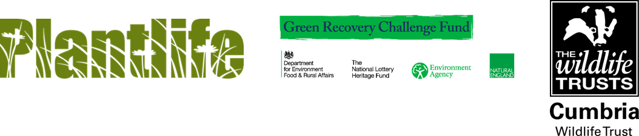

IS THIS YOU? INSPIRED TO BE THE NEXT GENERATION OF NATURE CONSERVATIONISTS?

Job Title: Grassland Trainee

Location: Kendal, Cumbria (initially home based)

This role will be based in Kendal, Cumbria. Although initially home based, induction, training and work will be a mixture of online, and in the office or field where this can be done in line with COVID-19 procedures. Training and meetings with other staff and partner organisations will be online at first but travel across Cumbria and further afield will be required at times.

Salary: National Living Wage (£8.91 an hour) plus pension contribution of 9%.

Duration: Full-time (35 hrs per week) fixed-term for 6 months, April 2021 – September 2021.

Plantlife and its project partners are seeking six enthusiastic, self-motivated individuals with a strong interest in conservation to become Trainee Meadow Makers and take part in a fully funded trainee programme. We are particularly interested in hearing from young people keen to develop a career in conservation.

Six full-time, fully paid (based on the National Living Wage) career entry positions are available. Each position is for six months, from April to September and will be hosted by Plantlife (x3), Cumbria Wildlife Trust, High Weald AONB and Yorkshire Dales Millennium Trust. You will work in areas including Herefordshire, Lancashire, Cumbria, Devon & Cornwall and East Sussex

The Meadow Makers project is taking place thanks to funding from the government’s Green Recovery Challenge Fund. The fund is being delivered by The National Lottery Heritage Fund in partnership with Natural England and the Environment Agency.

Deadline for receipt of applications Sunday 7th March at 9pm.

Interviews will be held online during the week commencing 15th March.

