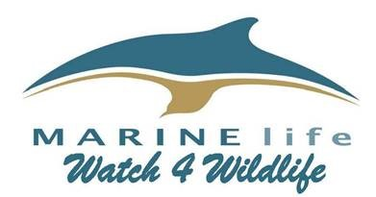

Join us for our identification course.
Cumbria Wildlife Trust, Plumgarths, Crook Road, Kendal, Cumbria, LA8 8LX

Thank you for booking a place.
Morning session 10.00 to 1.00
Lunch 1.00 to 2.00
Afternoon session 2.00 to 4.30

Tea and coffee will be provided but you will need to bring a packed lunch and snacks.

What to bring:

- note book and pen

- clip board

- packed lunch and snacks

What to expect:

The event is being run by experienced MARINElife research team leaders and will provide training on the identification of whales, dolphins and seabirds. This land based course will cover how to record scientific data when at sea on ferries or other ‘vessels of opportunity’.

We ask that you make every effort to arrive and return from breaks promptly. We are unable to delay delivery of the course for latecomers.

Details of MARINElife surveys, our survey routes and recent sightings can be found on our website www.marine-life.org.uk

MARINElife I Higher Street, Bradpole, Bridport, Dorset DT6 3JA 01308 425615
Company Registration Number 05057367 Registered Charity Number1110884

